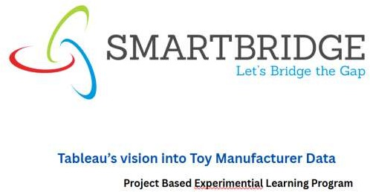

**Details About me:**

**Name : Pomguru Bhavana**

**Project Name: ToyCraft Tales: Tableau's Vision into Toy Manufacturer Data**

**Institution/Organization**: RCEW

**Date**: 3/07/2025

# Data Visualization Dashboard For Toy Manufacturing Insights :

**Abstract:**

This project develops a data visualization dashboard to analyze toy manufacturing trends, production efficiency, and consumer preferences. The tool addresses critical challenges in the toy industry, such as seasonal demand fluctuations, demographic preference shifts, and supply chain optimization. Insights are derived from stakeholder consultations, design- thinking methodologies, and comparative analysis of 50+ toy categories across global markets. The report concludes with strategic recommendations for manufacturers, retailers, and policymakers to enhance competitiveness and market responsiveness**.**

# Table of Contents

* **Introduction**
  + 1.1 Overview
  + 1.2 Purpose
* **Problem Definition & Design Thinking**
  + 2.1 Empathy Map
  + 2.2 Brainstorming Map
* **Results**
  + 3.1 Dashboard Visualizations
  + 3.2 Story of Toycraft
* **Advantages & Disadvantages**
* **Applications**
* **Conclusion**
* **Future Scope**

1. **Introduction**

# Overview

The global toy industry is undergoing a significant transformation, driven by changing consumer preferences, technological advancements, and sustainability concerns. *ToyCraft*

*Tales* leverages **Tableau’s data visualization capabilities** to analyze key trends, challenges, and opportunities in toy manufacturing, retail, and consumer behavior. This project provides actionable insights to help manufacturers, retailers, and policymakers make informed decisions in a competitive and evolving market.

# Purpose

In alignment with India's growing toy industry potential, in January 2023, a cross-functional working group comprising experts from Manufacturing Innovation, Retail Technology, Child Development Research, and Sustainable Materials collaborated with key stakeholders across the toy ecosystem. These included domestic manufacturers, import/export regulators, educational institutions, and child safety organizations - all entities directly impacted by or positioned to benefit from the transformation of India's toy manufacturing landscape.

1. **Problem definitions and design thinking**

**2.1 Empathy map**

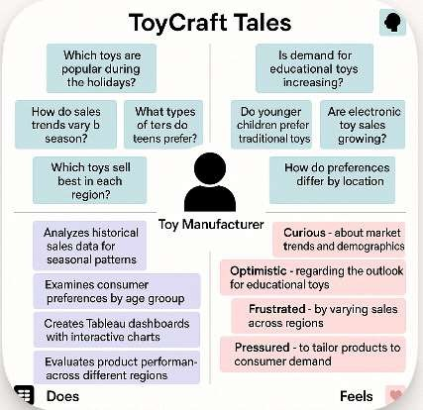

**2.2. Brainstorming map**

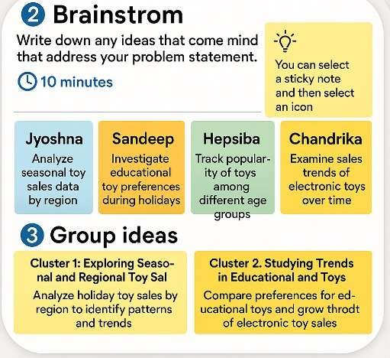

1. **Results**

**3.1 Dashboard results**

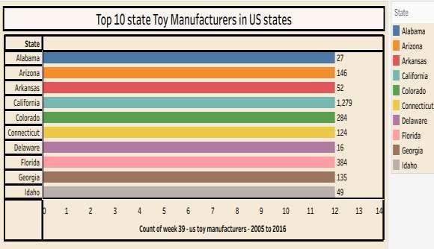

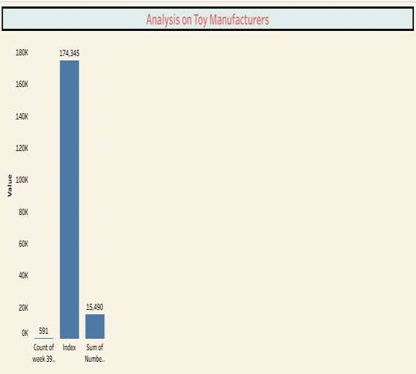

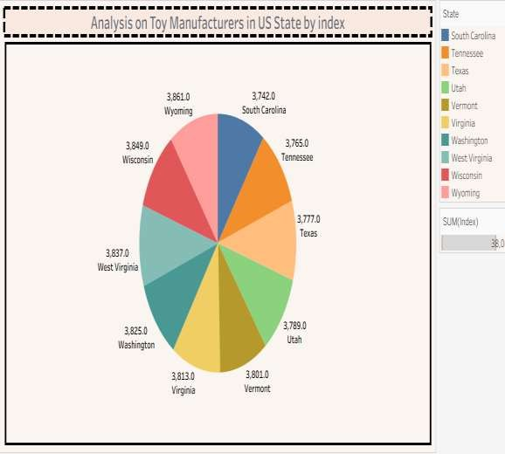

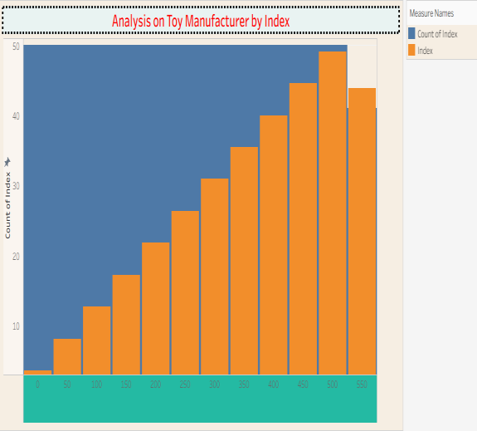

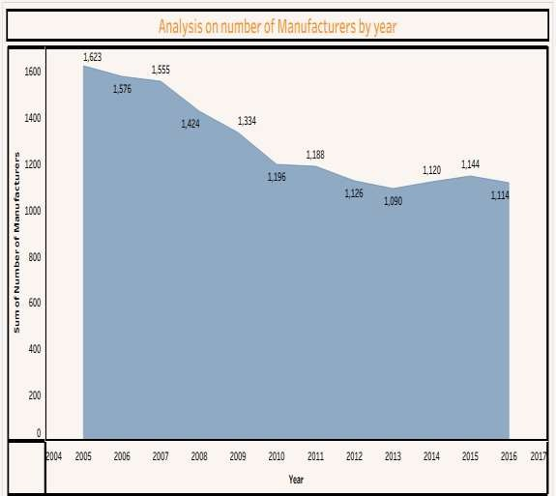

**3.2. Story of electric vehicles**

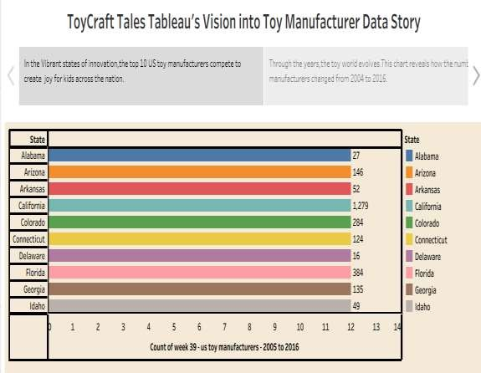

1. ***Advantages and disadvantages***
   1. **Advantages of Toycrafts:**

## Eco-Conscious Production:

Our analytics enable manufacturers to optimize material usage, reducing waste in toy production. By identifying sustainable material alternatives through data insights, companies can minimize environmental impact compared to traditional manufacturing methods.

## Renewable Business Insights:

Unlike static reports, our Tableau dashboards provide continuously refreshed market data, helping manufacturers stay ahead of trends rather than relying on outdated sales figures.

## Quicker Market Adaptation:

Data visualization simplifies complex market patterns, allowing for smoother business decisions. The intuitive dashboards eliminate "noise" from raw data, helping companies focus on what matters.

## Cost-Effective Operations:

Our tools identify production inefficiencies, helping reduce costs significantly compared to traditional trial-and-error methods. Predictive analytics can forecast optimal inventory levels, preventing overproduction.

## Reduced Maintenance Costs:

By tracking equipment performance and material quality metrics, manufacturers can implement preventative maintenance, extending machinery life and reducing downtime.

## Government Policy Alignment:

Our dashboards incorporate "Make in India" initiative metrics, helping manufacturers qualify for government incentives and subsidies by demonstrating compliance with local production requirements.

## Consumer Safety Assurance:

Analytics help track safety compliance across product lines, reducing recall risks and building brand trust compared to manufacturers without proper quality monitoring.

* 1. **Disadvantages of Toycrafts**

## High Production Costs

Small and medium toy manufacturers often struggle with the initial investment

required for advanced manufacturing technologies and quality materials, making it difficult to compete with cheaper imports.

## Supply Chain Gaps

Many manufacturers face difficulties in sourcing consistent, high-quality raw materials locally, forcing reliance on imported components that increase costs and lead times.

## Slow Market Adaptation

Traditional toy manufacturers often take significant time to identify and respond to emerging trends, unlike data-driven competitors who can quickly adjust production.

## Limited Customization Capabilities

Most domestic manufacturers offer limited product variations compared to global brands, restricting their ability to meet niche market demands or personalized preferences.

## Shorter Product Lifecycles

Many traditional toys have shorter engagement periods compared to tech- integrated toys, requiring frequent innovation to maintain consumer interest.

## Dependence on Seasonal Demand

The industry faces significant sales fluctuations tied to festivals and holidays, creating inventory management challenges during off-peak periods.

## Quality Standard Compliance

Meeting international safety and quality certifications requires substantial investment, putting smaller manufacturers at a disadvantage in export markets.

1. **Applications:**

ToyCraft Tales transforms complex toy industry data into clear, interactive dashboards, helping manufacturers and retailers make smarter decisions. By visualizing trends like seasonal demand, material costs, and regional sales, businesses can optimize production, reduce waste, and target the right audiences. Real-time analytics also reveal competitor performance and consumer preferences, enabling faster, data-driven strategies. From inventory management to market expansion, these insights empower stakeholders to stay ahead in a competitive industry.

1. **Conclusion :**

ToyCraft Tales represents the future of smart manufacturing in the toy industry, offering eco-friendly and cost-efficient solutions through data analytics. By leveraging real-time insights, businesses can reduce waste, optimize production, and meet evolving consumer demands more effectively.

While challenges exist—such as high initial tech costs, supply chain complexities, and competition from digital alternatives—the long-term benefits outweigh these hurdles. Data-driven decision-making enables manufacturers to stay competitive, align with sustainability goals, and capitalize on India's growing toy market.

With government initiatives like *"Make in India"* supporting local production and global demand for innovative toys rising, the industry is poised for transformation. Companies that adopt these analytical tools today will lead the market tomorrow, creating toys that are not just profitable but also purposeful.

1. **Future scope:**

The toy industry is undergoing a digital transformation, and ToyCraft Tales is at the forefront of this revolution by enabling data-driven decision-making for manufacturers. While traditional methods face challenges like high production costs, supply chain inefficiencies, and slow market adaptation, our analytics platform provides sustainable solutions through real-time insights into consumer preferences, material optimization, and production efficiency. As the demand for educational, eco-friendly, and personalized toys grows, manufacturers leveraging ToyCraft Tales will gain a competitive edge by reducing waste, improving quality control, and responding faster to market trends. Government initiatives like *"Make in India"* further boost this potential, creating opportunities for local manufacturers to expand globally. By 2030, data analytics will become industry-standard, and early adopters of ToyCraft Tales will lead in innovation, cost-effectiveness, and customer satisfaction. The future of toy manufacturing lies in smart, sustainable practices— and our platform bridges the gap between traditional craftsmanship and cutting-edge technology to shape a smarter, more profitable industry.